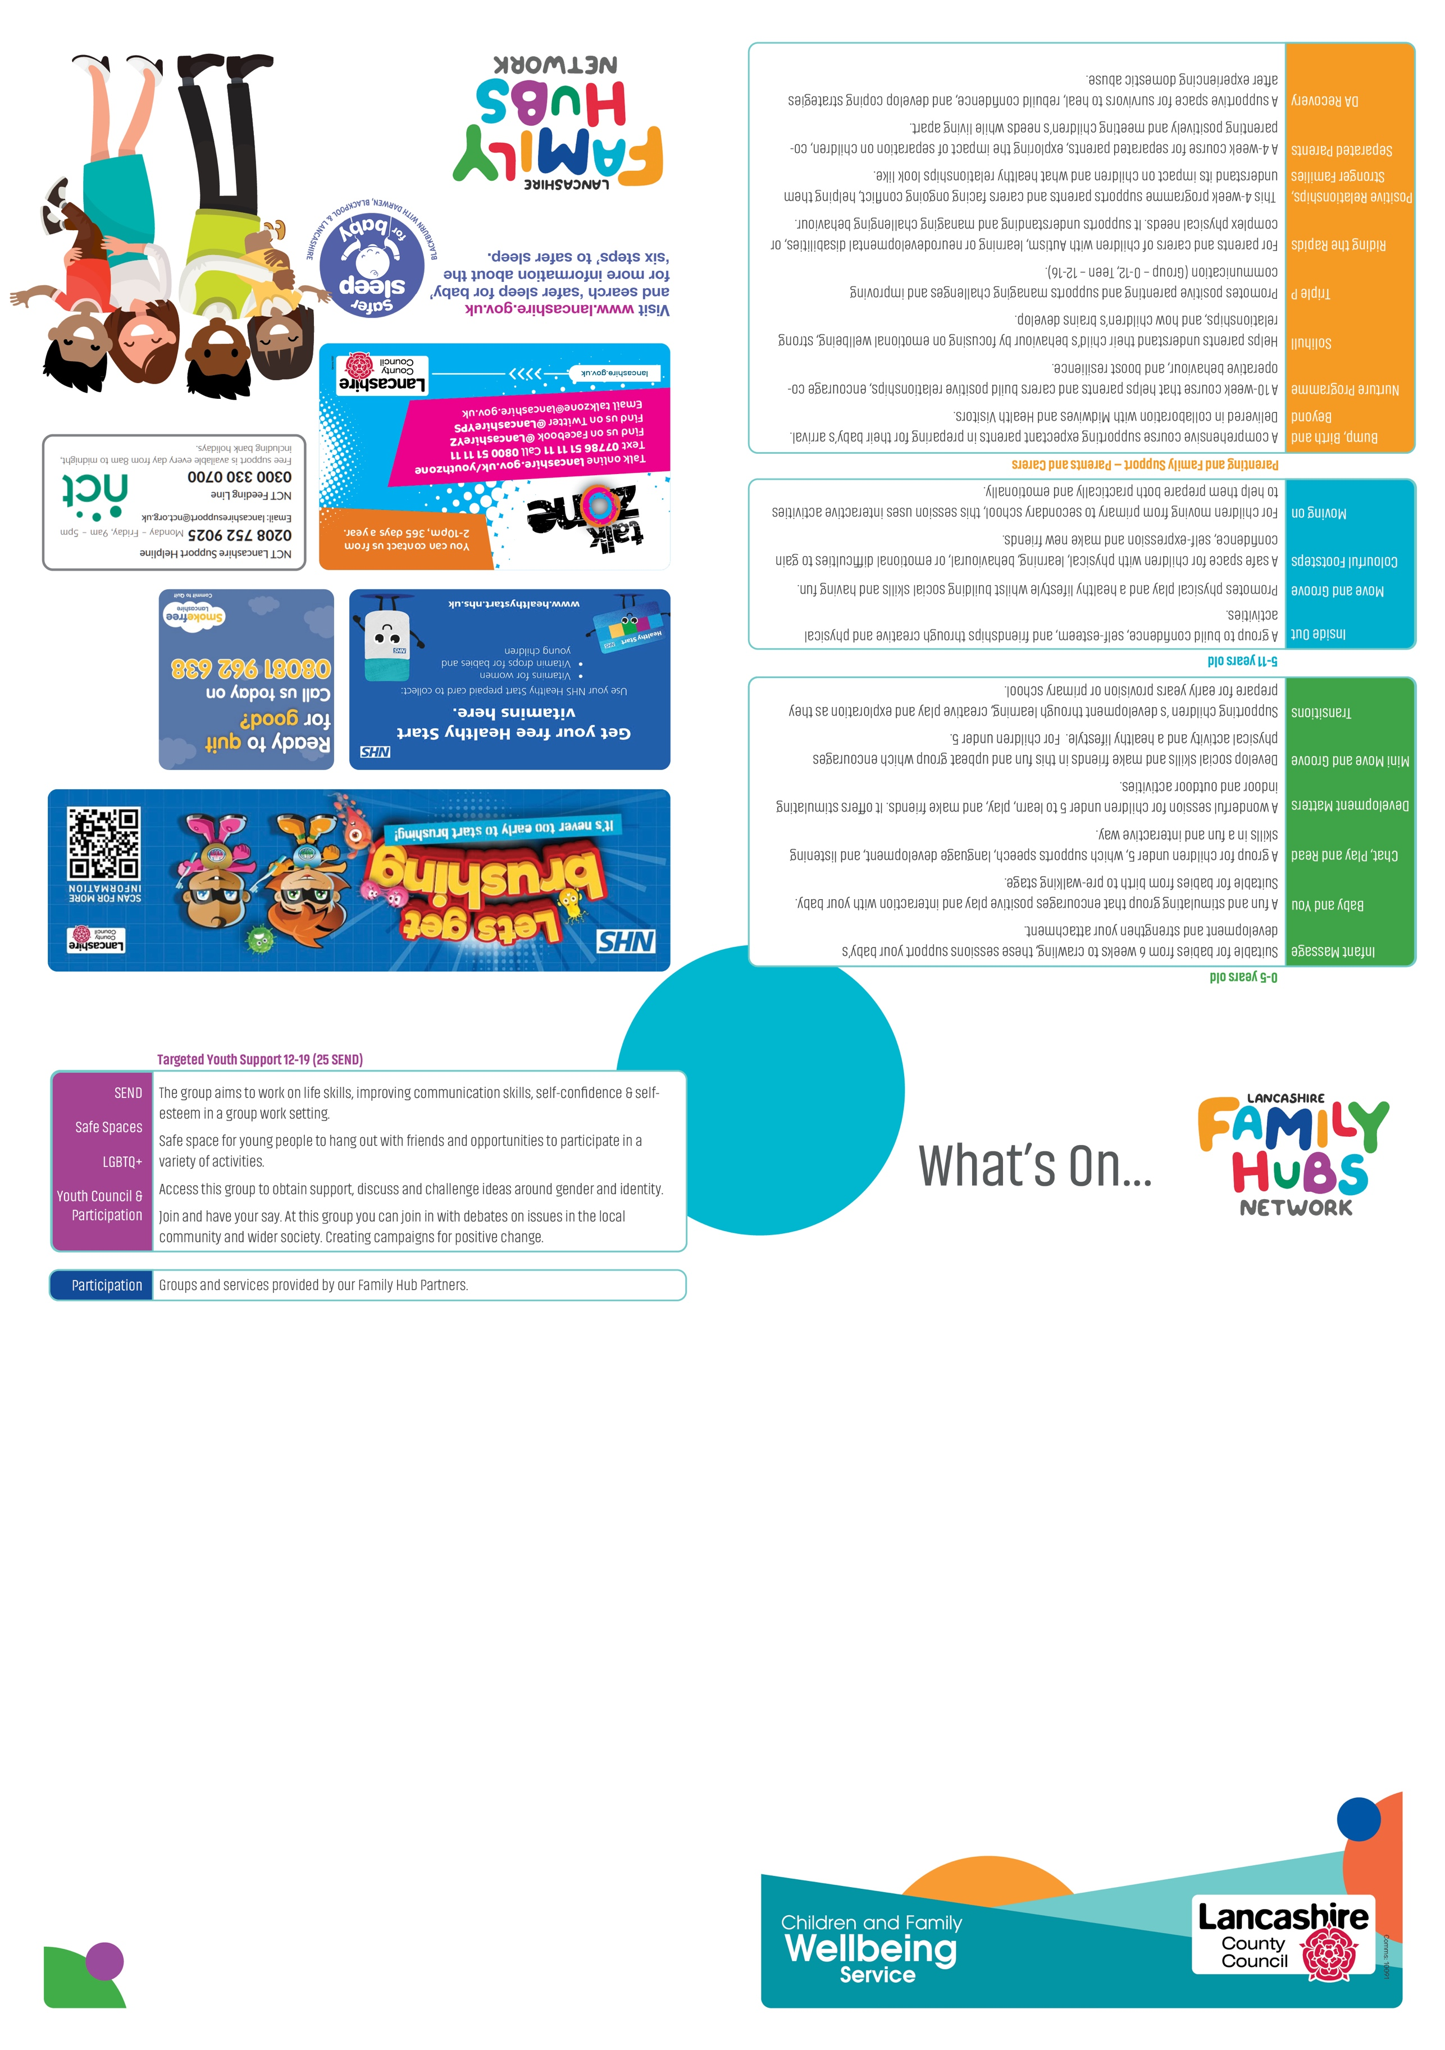

Welcome to our
SouthRibble Family Hubs
What's On Guide
September – December 2026
Please remember, all our groups are free
#HAF26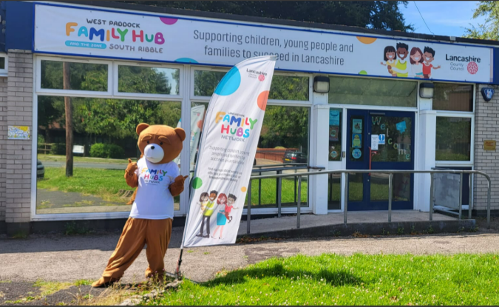

Useful Numbers
Childcare Funding 0300 1234097
Childline 0800 1111
Children's Services 0300 1236720
Citizens Advice Line 0800 1448848
Community Midwifes 01257 245116
Food Bank South Ribble 01772 930405
Health Visitors 0300 247 0040 Opt 1
Medical Advice 111
Mind Matters 01772 773437
National Breastfeeding Helpline 0300 1000212
National Domestic Abuse 0808 2000247
NCT Feeding Support Helpine 0300 3300700
NHS Dentist helpline 0300 3301348
Royal Preston Hospital 01772 522972
The Wish Centre 0300 5610440
Tippy Toes Baby Bank 07852304225

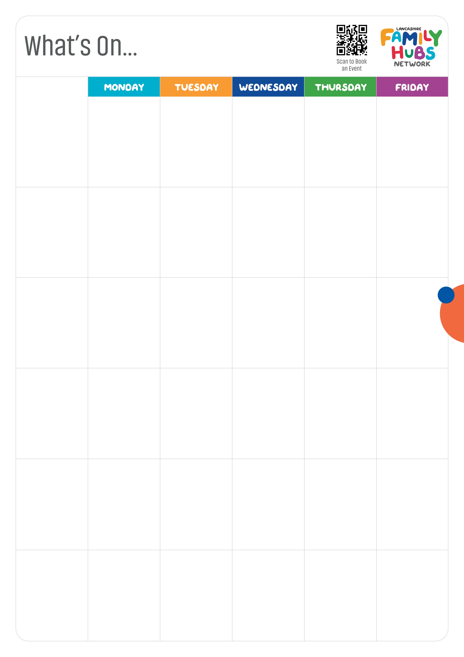
9:30am – 11am Busy Bees Development Matters
1pm – 2pm Sensory Play
5:30pm – 7:30pm Bump, Birth & Beyond 29th Oct & 5th Nov Bookable

9:30am – 11:30am One Stop Shop & SEND drop in (Every 3rd Wednesday of the month) 12:00 – 1pm Family Hub Forum Starting September (Monthly) 1.30pm – 3pm Infant Massage Bookable

Youth Support 12 – 19 years old (25 with SEND)
West Paddock Family Hub & the Zone West Paddock, Leyland Preston PR25 1HR
01772 532930

7pm – 9pm Safe Space & Detached Work
3:30pm – 5pm Step Up to Youth Work (8 – 11 yr olds)
7pm – 9pm Youth Council

4:30pm – 6pm Thrive

7 pm – 9pm POUT (LGBTQ+ Group)


South Ribble Children &
Family Wellbeing Service
www.southribblefamilyhub@lancashire.gov.uk
www.lancashire.gov.uk/events
September - December 2026

9:30am – 11am
Mini Move & Groove

26th Septemeber & (every 4th Saturday of the month going forward)
9:30am – 11am
Dad's & Male Carer group
19th September & (every 3rd Saturday of the month going forward)
9:30am – 11am
Fortnightly Colourful Footsteps
12th September & (every 2nd Saturday of the month going forward)

9:30am – 11:30am
Beehive Baby & You Development Matters
New Day Church Ward Street PR5 5HR

9:30am – 11:00am
Beehive Development Matters
St Aidan's Church Station Road PR5 6QR

6:30pm – 8:30 pm UNITE (SEND Group)

9:30am – 11am
Baby & You
9:30am – 11:30am
Baby & You with drop in weigh session (Every other Tuesday, from 8/09/26 limited to 15 spaces) Self weigh available

9:30am – 11am
Mini Move & Groove

Follow us on  for all up to date information

9:30am – 11:30am
Chat Play & Read Bookable

9.30am – 11am
Babbling Babies Baby & You Bookable

9.30am – 11.00am
Development Matters
1pm – 2:30pm/3pm
Baby & You with drop in weigh session (Every other Monday, from 14/09/26 limited to 15 spaces) Self weigh available

9:15am – 11:30am
Weigh, Stay & Play (Limited to 15 spaces) Self weigh available

9:30am – 11:00 am
Chat, Play & Read Bookable

1.30pm – 2.30pm
Magical Moments (2 – 7yr olds)

Saturday's activities
West Paddock Best Start In Life Family Hub West Paddock, Leyland Preston PR25 1HR
01772 532930

Other Delivery Venues

Kingsfold Family Centre Martinfield Road, Penwortham Preston PR1 9HJ
01772 532930

Walton-le-Dale Family Hub Brindle Road, Bamber Bridge Preston PR5 6YJ
01772 532930

West Paddock Best Start In Life Family Hub West Paddock, Leyland Preston PR25 1HR
01772 532930

